Draft Work in Progress

Commissioning Strategy 2007 /2008 to 2012/2013

Context
1. 1 National Context
1.1.1 .Background
The Primary Care Trusts in Hertfordshire form part of a broader National Health Service. Any strategy must therefore be cognisant of national policy drivers and East of England wide plans.

It is perhaps helpful to think of the national context in respect of the following three areas:

- Clinical reform
- The Patient Experience
- Organisational framework

1.1.2 Clinical Reform
Lord Ari D’arzi is currently undertaking a review of the NHS. The review is due to be published in July of 2008. However an interim report was published in October in 2007.
The interim report recognised some of the clinical drivers for change. These reflect the need to centralise some of the more specialist services in order to improve outcome and the changes in technology which will allow for more services to be provided in community settings closer to people’s homes. The interim report recognises that there is not one single blueprint that can be rolled out across the whole of the NHS i.e. the model to be consulted upon for London would not necessarily be appropriate across the whole of the country.

The next stages of the review therefore are to consider how the principles could be applied within SHA areas.

The white paper “Our Health, Our Care Our Say”, was issued in January 2006. The white paper set out to achieve four main goals:

- Better prevention services with earlier intervention
- Greater choice for patients with a greater say in their treatment
- Doing more to tackle inequalities and improving access to community services
- Providing more support for people with long term needs

Both the interim direction set by the Lord D’arzi report and the principles laid out in “Our Health, Our Care Our Say” are entirely consistent with “Delivering Quality Healthcare for Hertfordshire”.

Another important element of national policy relates to patient safety and the general adoption of good clinical practice. The National Institute of Clinical Excellence sets benchmarks for clinical practice across the NHS: Improving Outcome Guidance sets the standard for treatment of various cancer tumour sites: there are firm performance targets in respect of eradicating hospital acquired infections such as MRSA and C.DIFF

1.1.3 Patient Experience
There is a recognition that in the past services have been built around staff convenience rather than around patient’s needs. Patient experience is being improved through:

- Improved access to services through reducing waiting times. By December 2008 the maximum waiting time for treatment will be 18 weeks. There are new initiatives to improve access to GPs and dental practitioners.

- Improved patient choice this includes both improved convenience through initiatives like Choose and Book but also through greater patient involvement in their own care plan.

- Improved patient dignity through initiatives such as elimination of mixed sex wards and a move towards single accommodation in new buildings.

1.1.4 Organisational Framework
In order to support the reform programme there have been a number of organisational and structural changes These have included:

- Commissioning a Patient Led NHS which set to establish stronger PCTs more focused on their commissioning role with provider services being managed more at an arm’s length.

- The development of Practice Based Commissioning Groups in order to strengthen local clinical engagement in shaping services

- The development of payment by results to make the commissioning process more transparent and to incentives clinical redesign.

- The development of Foundation Trusts to strengthen the governance arrangements in provider units

Running hand in glove with theses organisational requirements is a requirement to greater increase the levels of public and patient involvement within the decision making process.

1.2. East of England Context
1.2.1 Background
East & North Hertfordshire Primary Care Trust and West Hertfordshire Primary Care Trust are part of the boarder East of England Strategic Health Authority. The East of England covers the counties of Hertfordshire, Bedfordshire, Essex, Norfolk, Suffolk and Cambridgeshire. The Strategic Health Authority is responsible for the development of overarching strategies and the performance management of the NHS within its boundaries. The two key documents affecting the development of the commissioning strategy for the Hertfordshire Primary Care Trusts are:

- Saving Lives Improving Lives
- Looking to the Future
1.2.2 “Improving Lives; Saving Lives”
Sets out a vision for the NHS within the East of England. It sets out eleven pledges:

- We will deliver year on year improvements in patient satisfaction.
- We will extend quicker access to our services.
- We will make it easier to see a GP at a more convenient time.
- We will ensure NHS dentistry is available to all who want it.
- We will ensure fewer people suffer from or die from heart disease/cancer
- We will aim to make our healthcare system the safest in England
- We will improve the lives of those with long term illness
- We will half the difference in life expectancy between the poorest 20% of our communities and the rest of the East of England.
- We will ensure healthcare is available to marginalised groups and “looked after children” as it is to the rest of us.
- We will cut the number of smokers by 140,000.
- We will halt the rise in obese children and then seek to reduce it.

1.2.3 Looking to the Future is a review of Acute Services across the East of England which was instigated by the Strategic Health Authority. The purpose of the review was to establish whether the current pattern of service provision is clinically and financially sustainable and if not what changes need to be considered. The first phase of the review was a technical analysis which was published in December 2006.

The technical analysis set out the current position in terms of activity levels, catchment populations and population projections. It then considered current and emerging national guidance on the configuration of acute hospital services and to what extent acute services in East of England were in line with these guidance. It then looked at the full requirement of the European Working Time Directive, travel times, planning developments and the overall position.

The report was the basis for establishing a number of work streams across the SHA. These work streams are:

- Emergency Care
- Surgical
- Maternity and neo natal services
- Paediatrics
- Out of hospital care
- Workforce
- Technical issues

The technical analysis within looking to the future was cognisant of the work underway in Hertfordshire on “Delivering Quality Healthcare in Hertfordshire” and recognised the need to proceed with that work and to go out to consultation.

1.3. Local context
1.3.1 Historical financial position in Hertfordshire
DN INSERT FROM PRESENTATION TO ANNUAL MEETING

1.3.2 Investing in your Health
In March 2003 the NHS in Bedfordshire and Hertfordshire set out its vision for improving local health care in a document called “Investing in your Health”. This then became the subject of public consultation. Following consultation it was agreed that the NHS in Hertfordshire and Bedfordshire should:
- Move more routine care out of secondary care and into community and primary care settings.
- Separate emergency care from planned care
- Concentrate in patient acute and emergency care on two main hospital sites.
- In West Hertfordshire this would involve a major refurbishment and rebuilding works at Watford. In East and North Hertfordshire this would involve a new hospital at Hatfield and the QE2 would be closed.
- To relocate the cancer services for Hertfordshire residents from the Mount Vernon Cancer Centre into the new hospital at Hatfield.

1.3.3 Investing in your Mental Health
“Investing in your Mental Health” (IIYMH) was agreed as the joint mental health strategy across Bedfordshire and Hertfordshire early in 2006. The strategy was predicated on the recognition that one in four of the population will suffer some form of mental heath problem during their lifetime. IIYMH aims to break this cycle. The strategy is underpinned by a number of principles.
- The Recovery
Each persons route to recovery is unique IIYMH would seek approaches that reflect the needs of the individual and develop ways of helping people on their own journey to a better quality of life.

- Social Exclusion/inclusion
People with long term mental health problems suffer most from social exclusion. The stigma associated with even mild forms of mental health problems is such that people hide them. May people with long term mental health problems can be forced to the margins to what others would consider to be a “normal” life of work, pleasure, family and friends that they are said to be excluded and almost hidden from society.

- Main streaming services
Means that no one using specialist mental health should be denied access to main stream health service because of his or her age or particular mental health problem. Likewise, service users should not be segregated from other members of the community into specialist services when there are main stream services that can meet their needs.

- De stigmatise Mental Health
Through educating people (including other health care practitioners) and better understanding of mental health to provide early identification and access to services.

To pursue these principles the IIYMH strategy put forward an approach that: would involve:

- Fewer inpatient services and more day care services. The inpatient facilities would be at the Lister, QE2 and Hemel Hempstead sites.

- Providing more and better community based services to provide support and help closer to where users/carers live.

- Better specialist specialised services for those with serious problems and better short term care in emergencies

- Working more closely with other organisations such as local authorities, voluntary organisations and other groups so that a wider variety of services could be provided and more choice offered to users.

To achieve this, an investment plan was proposed for funding new services through a combination of recycled funding resulting from re configuration of existing provision, alongside additional increased levels of investment. Re configuration/reinvestment was based on repatriation of out of county based services and a reduction in bed numbers. A long term model of in patient provision was also proposed based on the developmental assumptions of Investing in your Health.

1.3.4 Delivering Quality Healthcare in Hertfordshire
In the autumn of 2006, it became clear that there were significant issues with the affordability of the new hospital at Hatfield. This led to the new Primary Care Trusts and the two Acute Trusts reviewing the assumptions which underpinned Investing in your Health. Some of the key assumptions remained valid. These included:

- The clinical need to move to two main acute hospital sites in Hertfordshire if we are to improve the quality of care and maintain a sustainable acute hospital service.

- For many medical conditions the shift of care into the community and out of major hospitals is still the right course.

- The separation of planned and emergency surgery would have benefits in terms of better through put, minimising the need to cancel operations and helping reduce the incidence of hospital acquired infections.

Delivering Quality Healthcare in Hertfordshire was consulted upon between June and September 2007. Based on the outcome of this consultation, the Boards of the 2 PCTs and the 2 Acute Trusts met on the 19th of December and agreed on the following

- Emergency and Acute Services in East & North Hertfordshire should be consolidated on the Lister hospital site
- Two local general hospitals would be commissioned in Hemel Hempstead and in Welwyn Garden City to provide substantial centres of care for the local communities
- A network of eight urgent care centres would be commissioned to provide access for about two thirds of patients who currently attend A&E departments
- Children’s emergency and planned day surgery services in West Hertfordshire should be centralised at Watford General hospital
- The long term location of an elective care centre in West Hertfordshire should be at St Albans City hospital
- Additional funding would be made available to support access to emergency care and also to support an enhanced local transport schemes

1.3.5 Hertfordshire Local Area Agreement
A new Local Area Agreement (LAA) is being developed to commence in April 2008. The current LAA will continue until March 2009 to complete its three year period as planned. It is expected that many of the targets in the current LAA will be reflected in the new LAA, however the next LAA will be based on the new national indicator set published following the announcement of the Comprehensive Spending Review in October 2007. For the new LAA approximately 35 indicators (plus 16 DfES) will be selected for Hertfordshire from the total set of 198. It is assumed at this stage that the 35 indicators will be split equally across the four current theme areas.

The priorities for the new LAA will be informed by:
- The Hertfordshire Sustainable Community Strategy, currently out to public consultation
- National priorities
- Current indicators and targets in LAA1
- Local work to develop new target areas for the LAA

The County Council is responsible to Government Office for negotiating and delivering the targets within the LAA, however partners in the LAA now have a statutory duty to co-operate. The public sector will have to report on the total set of 198 indicators (many are shared health and social care responsibility) and these will form the basis of the new Comprehensive Area Assessment. Selecting up to 35, with most significance for Hertfordshire, for inclusion in the new LAA will focus partners to work together on these and develop more detailed targets and projects to support achievement of the indicators.

- There are four themes within the current LAA:
- Safer and Stronger Communities
- Children and Young People
- Healthier Communities and Older People
- Economic Prosperity

East of these themed areas is led by a partnership executive group. Health (PCT) and Social Care (Adult Care Services) jointly lead the Healthier Communities and Older People theme. The PCTs also have representation on two of the other partnership executives: Chief Officers Group for Safer and Stronger Communities and the Children’s Trust Partnership. Each theme contains targets over three years and there are a set of reward targets which contain “stretched” performance goals. If the reward targets are achieved there are financial rewards for Hertfordshire totalling £30m if all the targets are met. The reward money will be split 50/50 between the 10 LSPs and the 4 strategic partnerships. The reward money is a mix of capital and revenue.

The new LAA will be based on the priority areas identified for Hertfordshire within the 2021 Sustainable Community Strategy. As this is being consulted on, until February 2008, the themes are not definite yet. The nine themes being consulted on are:

- Safer and Stronger Communities
- Affordable Housing and Quality Neighbourhoods
- Children and Young People
- Transport and Access
- Jobs, Prosperity and Skills
- Health and Wellbeing
- An Ageing Population
- Sustaining Hertfordshire’s Unique Character and Quality of Life
- Promoting Sustainable Development

It is envisaged that the new LAA will have targets focused on “place” and “people” groups thus addressing health inequalities and areas of deprivation across the County. This fits with the “place shaping” agenda of local government. The new agreement will be negotiated with Government Office Eas5tt between January and March 2008, with final sign off by Ministers by June 2008.

1.3.6 Benchmarking Existing Performance
Table 1: Standardised Activity Rates per 1,000 Weighted Population, 2005/06

Organisation | Standardised activity rates per 1,000 weighted population
 | Elective | Non elective | Total
Cambridgeshire PCT | 124.7 | 103.8 | 113.3
South East Essex PCT | 118.5 | 105.8 | 116.6
Suffolk PCT | 109.4 | 100.5 | 104.6
West Essex PCT | 111.5 | 93.9 | 101.9
Norfolk PCT | 116.7 | 88.5 | 101.3
West Hertfordshire PCT | 104.1 | 98.3 | 101.1
Peterborough PCT | 103.4 | 93.8 | 98.2
Luton PCT | 82.9 | 109.2 | 97.2
East & North Hertfordshire PCT | 100.5 | 90.7 | 95.2
Mid Essex PCT | 89.0 | 97.3 | 93.5
Gt Yarmouth and Waveney PCT | 106.7 | 79.9 | 92.2
North East Essex PCT | 93.6 | 91.1 | 92.2
Bedfordshire PCT | 92.5 | 91.0 | 91.6
South West Essex PCT | 89.8 | 88.9 | 89.3
East of England | 105.0 | 95.0 | 99.6
England | 100.0 | 100.0 | 100.0

Total outpatient attendance rates per 1,000 weighted populations for each PCT across East of England for the first quarter of 2006/07 are shown in Table 2. Again, there is considerable variation across East of England.

Organisation | Total OP attendance rate per 1,000 weighted population  (All specialties) | Standardised OP attendance rate (All specialties)
Cambridgeshire PCT | 941 | 120.6
South East Essex PCT | 920 | 118.0
Peterborough | 884 | 113.4
Suffolk PCT | 832 | 106.7
South West Essex PCT | 828 | 106.1
West Hertfordshire PCT (2) | 811 | 103.9
Bedfordshire PCT | 807 | 103.4
Mid Essex PCT | 790 | 101.2
West Essex PCT | 785 | 100.6
East & North Hertfordshire PCT (2) | 774 | 99.2
Gt Yarmouth and Waveney PCT | 773 | 99.1
Luton PCT (2) | 693 | 88.9
North East Essex PCT | 639 | 82.0
Norfolk PCT | 633 | 81.1
East of England | 776 | 99.5
England | 780 | 100.0

- excludes obstetrics
- (2) Follow up data for these PCTs is drawn from Dr Foster rather than QM08 returns, due to incomplete QM08 returns
Section 2
Our Vision and Values
Our ambition is to be high performing PCTs recognised by our people, patients and partners as providing outstanding care and improving the wellbeing of all
Caring | I care about everything I do for colleagues, patients and partners
Confident | I am trusted to make informed and timely decisions and have the confidence to see them through.
Creative | I have the freedom to bring forward new ideas and solutions
Learning | I take responsibility for my p[personal development as part of our learning culture
Fun | I play my part in making this an enjoyable and rewarding place to work
Proud | I am proud to work for the PCTs

Section 3 Improving Health

3.1 Health Inequality

Relatively poor health can be identified in specific geographical areas-often a proxy for socio-economic group or income and in population groups e.g. in Black and Minority Ethnic (BME) communities. Inequalities in health are the result of different life experiences between socio-economic, ethnic and marginalised groups and the general population, and between men and women. The same diseases, such as cardio-vascular disease, cancer and respiratory illness, affect all of the population but those in groups and geographical areas of disadvantage die at younger ages.

Hertfordshire is generally considered an affluent county. However, it has particular health inequalities between Black and Minority Ethnic groups including Gypsy Travellers, migrant workers, other groups and the general population. In addition there are other groups within the population of concern, for example, children in care, prisoners and those with mental health problems. In general these groups have worse health than the general population. There are also considerable geographical inequalities within the county and Local Authority populations as demonstrated by the Annual Public Health reports (Insert link).

Improving health and well-being is dependent on tackling underpinning social, environmental and lifestyle factors and the causes of death and ill-health through appropriate action (see Figure below). Social inclusion can be promoted through removing the barriers to social exclusion.

Tackling health inequalities requires action across all a range of organisations and sectors, including health and Social Care, district and borough councils, Third sector, Private sector etc. The PCTs are committed to identifying NHS actions to tackle inequalities in health through improving access to health and social care and targeting health improvement services to those with the poorest health.

3.2 Health Equity

We can consider equity (fairness) in two ways. Distributing resources equally to all is fair. Alternatively we can allocate resources in relation to the health needs of different groups and areas. Both approaches are fair but only the latter approach is likely to reduce health inequality in a population. For NHS services, such inequities might occur in resource allocation, commissioning, service provision or care outcomes.

Assessing the extent of current inequity and carrying out specific actions to address will often mean focussing on very specific aspects of health needs and services. Rather than use a wide variety of such data in this strategy, we have chosen to focus on two broad areas that highlight variation in health experience across the county: life expectancy and infant mortality. For individual services or client groups, more detailed work will still be required.

Figure Improving health and wellbeing

Underpinning factors:  - Social  - Environmental  - Economic | Lifestyle factors:  - Tobacco  - Obesity, diet, physical activity  - Alcohol  - Sexual health | Causes of death & ill health:  - Cancer  - Circulatory disease  - Respiratory disease  - Mental health  - Chronic conditions with complex health & social needs
Joint actions on wider determinants:  - Employment, inc. NHS as good corporate citizen  - Sustainable development & climate change  - Local Strategic Partnerships  - Local Area Agreements  - Regional economic & spatial strategies,  - Overview & scrutiny | Major lifestyle programmes, e.g.  - Tobacco control  - Obesity & childhood obesity  - Healthy diet & physical activity  - Improved sexual health  - Alcohol harm reduction  - Substance misuse | Best possible services:  - National service frameworks  - National guidance – NICE  - Patient safety & quality  - Reform, reconfiguration  - Focus on deprived groups  - Focus on primary care & long term conditions

3.3 Life Expectancy

A key priority for the NHS is to increase the health of the population as measured by an increase in life expectancy. The national life expectancy target is 78.6 years for men and 82.5 years for women by 2010. Figures below show that over the last fourteen years there has been a steady increase in life expectancy in both men and women.

However, despite this overall upward trend, there are considerable variations between and within local authorities.

E&N Herts
Both men and women living in Stevenage lie close to the England average whereas other areas are clearly above the English life expectancy trend for both men and women (Figure ). The life expectancy target for women is the most challenging for the population living in Stevenage (Figure ). The differences for life expectancy between the different areas of East Hertfordshire are mirrored by the length of healthy life expectancy without ill-health for a period of up to five years, as shown in Figures 4 and 6

West Herts
Watford lies close to or below the England average whereas other areas are clearly above the English life expectancy trend for both men and women (Figure). The life expectancy target for women is the most challenging for the population living in Watford, Dacorum and Hertsmere council areas. The differences for life expectancy between the different areas of West Hertfordshire are mirrored by the length of the years without ill-health as shown in the following figures.

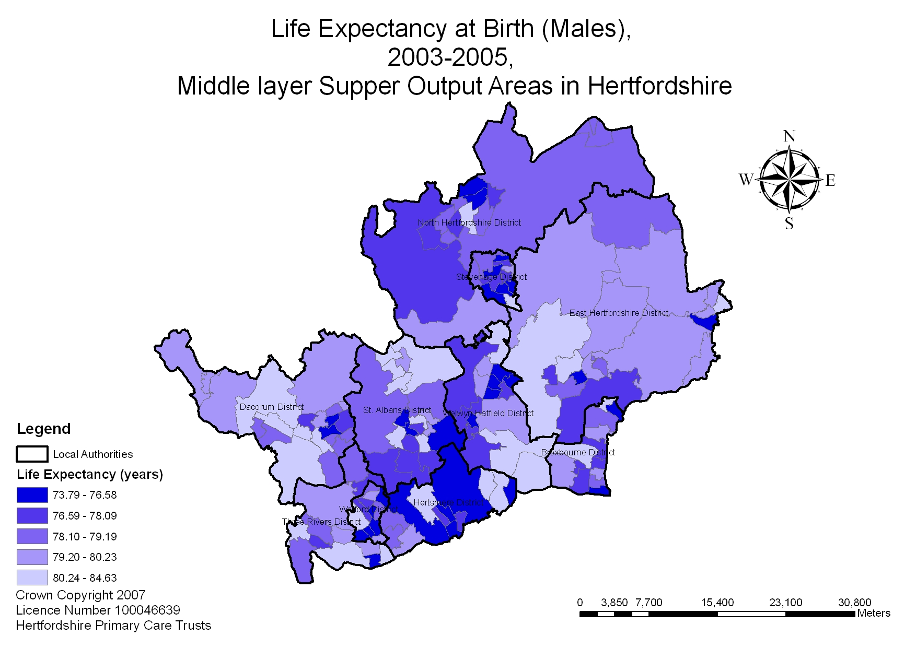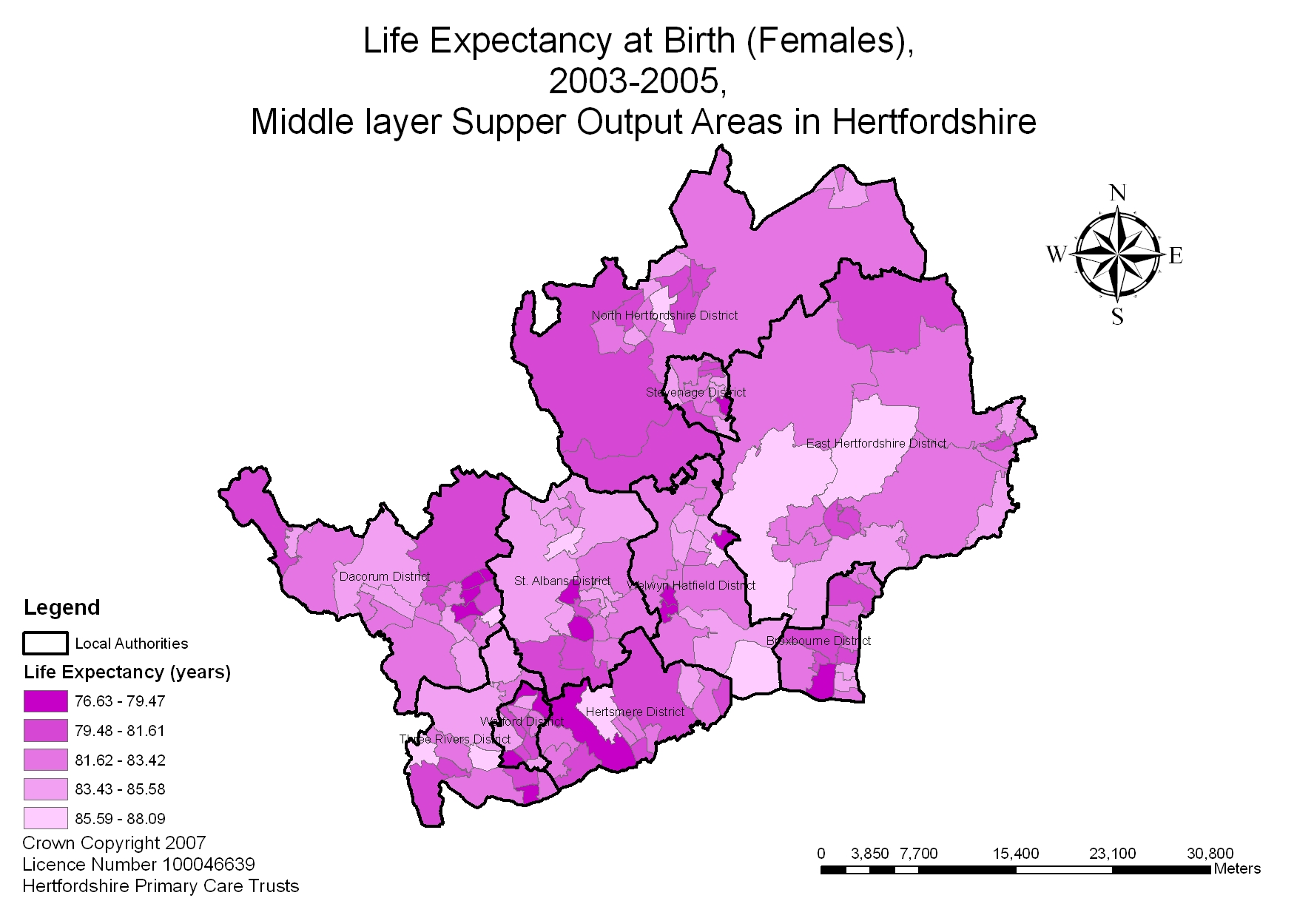
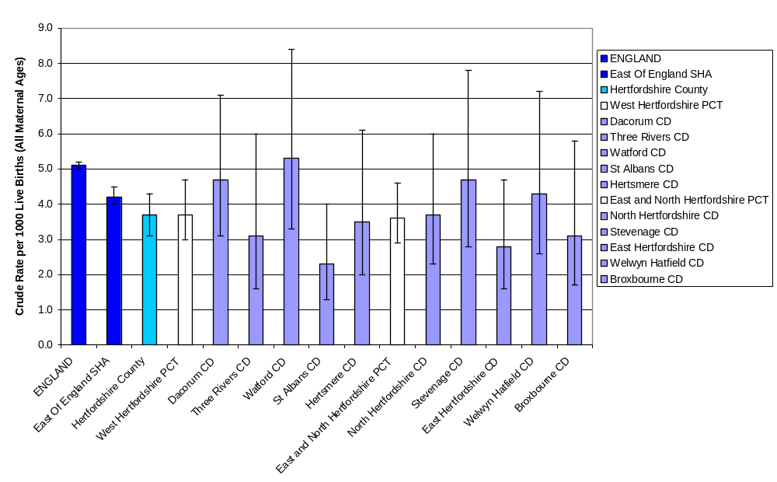
3.4 Proposed Key Actions
To tackle health inequalities a programme of action is needed to target the most disadvantaged groups, addressing the underlying social, economic and environmental causes of poor health and the lifestyle factors together with targeting services to address specific health needs. The focus needs to be on addressing barriers to access to services and uptake for people and communities affected by health inequalities, primarily in terms of geography, ethnicity and gender.

Additional action is required to address information issues, both in terms of providing appropriate and accessible information to disadvantaged groups (e.g. suitable for cultural, literacy and language needs) and collecting data to monitor uptake of services by those in need e.g. better collection of data on ethnicity to support equity audits.

In order to reduce by 10% health inequalities measured by life expectancy at birth and the infant mortality rate, the single most important factor is the reduction of smoking - in pregnancy and in disadvantaged groups - according to Tackling Health Inequalities: What Works. There is already a regional tobacco control strategy Smoke Free East and a programme of action.

 | Increase life expectancy | Reduce infant mortality
Reduce smoking rates, in pregnancy &among disadvantaged groups | Reduces cancer  Reduces heart disease, stroke and lung disease | Reduces number of low-birth weight babies
Improve access to diagnostic tests/care | Detect cancer at earlier stage | Better and earlier ante-natal care
Reduce delay in patients reporting symptoms to GPs | Detect cancer / heart / lung disease at earlier stage | Better and earlier ante-natal care
Increase uptake of screening & flu / other immunisation, management of blood pressure, cholesterol, and other risk factors | Detect cancer at earlier stage, take steps to reduce progression of heart disease or prevent acute exacerbation of chronic lung disease | Screening for antenatal problems, immunisation of mother / infant
Improved home conditions | Reduce excess winter deaths, by addressing fuel poverty | Better maternal nutrition in disadvantaged groups
Reduce alcohol consumption | Reduce deaths from cirrhosis / chronic liver disease | Reduce unplanned pregnancy and fetal alcohol syndrome
Improve service quality | Implement IOG /NSFs for CHD, stroke etc | Implement NSF
Reduce accidents | At home and on the roads | -
Reduce teenage pregnancy | - | Rates of infant mortality are higher in this group
Provide family / parenting support | Support to those with chronic conditions | e.g. to reduce risk factors for SIDs

There needs to be a focus on ensuring access to high quality primary care in disadvantaged areas, reaching out to those who have low use but high need or experience barriers to access such as transport, language or disability, ensuring equitable uptake of prevention, screening and health protection services. This could include, for examples information and services for migrant workers. Health improvement programmes such as health trainers and life check programmes need to be focussed on health inequalities.

The use of health equity audit for service planning, commissioning and delivery was a standard in the Healthcare Commission 2004/5 annual health check- this needs to be approached systematically. A joint strategic needs assessment, as recommended in the Commissioning Framework for Health and Wellbeing¹¹ will be a requirement on PCTs and top tier local authorities. There is a need to work and develop targets in partnership. Examples include the current Local Area Agreements (LAAs), with mandatory health inequalities targets, through the Local Strategic Partnerships (LSPs) and Children’s and Young People’s Plans.

“
Section 4

4. Modernising Healthcare in Hertfordshire

4.1 Primary and Community Care
There are many compelling reasons why care should be moved out of acute hospitals and delivered safely and effectively in local facilities either in the community or in people’s homes. These include:
- Providing care closer to individuals homes through the further development of community based services such as diabetes and other specialist nurses for respiratory diseases etc
- Ensuring access to healthcare across the county is as equitable as possible
- Improving the management of chronic diseases to prevent unnecessary admissions including improved health promotion, health prevention and case management support
- Allowing acute hospitals to focus on their primary purpose of specialist care such as emergency surgery and complex medical and surgical procedures.
This is very much in line with the Governments white paper “Our Health, our Care our Say: a new direction for Community Services”. Achieving this direction will underpinned with a significant shift in resources. Across West Hertfordshire PCT the planned expenditure on primary community care for 2007/8 was xxxxxxxxxx million and it was intended that this will increase to yyyyyyyyymillion in 2013/14. In East and North Hertfordshire Primary Care Trust the current funding increase will be from xxxxxxxxxxxxxmillion to yyyyyyyyyyyyy,million.

4.2 Acute Hospital Care
Within Hertfordshire, acute and emergency care is provided by four small district general hospitals:
- Lister hospital at Stevenage
- QE2 hospital in Welwyn Garden City
- Hemel Hempstead General hospital
- Watford General hospital

This configuration is no longer clinically sustainable. Research has shown that treatment for the severest forms of heart attacks with primary angioplasty will reduce deaths if performed within the first hours of a heart attack. Bringing cardiac care together on to fewer sites means that they type of services can be offered to more patients in Hertfordshire.

Clinical sub specialisation has undoubtedly improved outcomes for patients. However, in order to achieve this level of specialisation requires clinical staff to see critical mass of patients in order to maintain and improve their expertise. This has become more and more difficulty at smaller district general hospitals.

There is a greater reliance on new technologies. Getting stroke patients to a specialist centre and treatment started quickly is crucial as their condition deteriorates and more cells in the brain die every minute that treatment is delayed. Stroke patients need to be assessed by the paramedic taken directly to the specialist centre for a CT scan, correctly diagnosed started right away on clot busting treatment. In order to provide such a service each hospital needs to have at least 2 CT scanners on site and that these are available on a 24 hour basis. Again this is not viable on smaller district general hospital sites.

Clinical studies have highlighted the importance of having experienced staff managing the care of patients in acute hospitals. Mortality rates are lower for patients undergoing procedures during the day when there is better availability of consultants to supervise care. In the past, there has been an over reliance on junior doctors to provide medical cover. The scope for this will decrease with the European working time directive which will limit the number of working hours to 48 in 2009. Whilst care predominantly provided by consultants will benefit patients, it will not be possible to provide this within smaller units.

It used to be the case that if patients were involved in a major trauma the most important factor to their survival was how quickly they could get to a hospital. This is no longer the case. Ambulance and paramedical services are now highly skilled in assessing and stabilising acutely ill patients. In his report “Emergency Access and Clinical Case for Change” Sir George Alberti the National Director for Emergency Access stated that long ambulance journeys do not lead to more deaths. If they did, patients in America and Australia, where ambulance journeys are much longer, would have higher mortality rates. What is clinically important is that patient receives specialist care delivered by experienced and specialist staff in specialist centres.

The Delivering Quality Healthcare in Hertfordshire consultation concluded that centralising acute and emergency services on two sites within Hertfordshire would have the following benefits:

- Larger bed units save more lives
- Specialist doctors save more lives
- New technologies – used by specialist staff – save more lives
- Availability of consultants save more lives
- Meeting the different needs of children and young people improve their quality of life
- Improving paramedic skills save more lives

4.3 Mental Health Services
DN TO BE INSERTED

Section 5
5 Commissioning Clinically Effective Services
5.1 Primary and Community Care

5.1.1. General Practitioner Services

DN Andrew Parker

5.1.2 Dentistry
DN Andrew Parker

5.1.3 Pharmacy Services
DN Andrew Parker /Heather Grey

5.1.4 Optometrist Services
DN Andrew Parker

5.1.5 Urgent Care:
As we move towards having two major A&E departments within Hertfordshire, it is important to balance access to services with clinical safety. Analysis has shown that about 65% of people who currently attend A&E departments do not require the full facilities of such an establishment.
Urgent Care covers a range services provided to people who require - or perceive the need for - urgent advice – diagnosis, care or treatments. Patients and carers rightly expect consistent and rigorous assessment of the urgency of their care, and an appropriate and prompt response to that need at all times. An appropriate response may include anything from telephone advice, reassurance and self care, through to face to face consultation with a clinician resulting in an admission to hospital with specialist facilities. Wherever clinically safe, care should be delivered as close to home as possible within a community setting.

A network of 8 urgent care centres will be commissioned across Hertfordshire. Two will be co located with the major A&E departments at the Lister hospital and Watford General hospital; two 24 hour /7 facilities will be provided at local generally hospital sites at Welwyn Garden City and at Hemel Hempstead; and four smaller units will be provided at Herts & Essex hospital Bishop Stortford, Cheshunt Community hospital, Hertford County hospital and the St Albans City hospital.

The services provided at the Urgent Care centres will be fully integrated with GP Out of Hours services. A pilot for the Urgent Care centres will be at Hemel Hempstead and will be operational from the autumn of 2008.

5.1.6 Outpatient Services:
In 2005/06 residents of Hertfordshire attended over 900,000 outpatient appointments in more than 350 different locations. Many more of these will be provided closer to where patients live:

- Some activity will be undertaken in GP surgeries thereby reducing the number of outpatients appointments needed elsewhere
- Some will be undertaken by GPs with special interests who have advanced training and a special interest in a particular area of medicine. They will see their own patients and patients of other GPs.
- Some will be undertaken by specialist nurses or other health care professionals such as physiotherapists
- Some will be undertaken by consultants but in more local settings

The table below analysis’s how the pattern of outpatients will change by 2012/13

Outpatient speciality | Manager in Primary Care |  | GPs with Special Interest |  | Specialist nurse, AHP |  | Acute Care including outreach
 | % | No. | % | No. | % | No. | % | No.
Cardiology | 10% | 4,540 | 10% | 4,540 | 20% | 9,080 | 60% | 27,240
Dermatology | 10% | 5,360 | 20% | 10,720 | 10% | 5,360 | 60% | 32,160
Gastroenterology | 10% | 2,100 | 10% | 2,100 | 20% | 4.200 | 60% | 12,600
Respiratory medicine | 10% | 1,940 | 20% | 3,880 | 10% | 1,940 | 60% | 11,640
Other medical specialities | 10% | 24,540 | 15% | 36,810 | 5% | 12,270 | 70% | 171,780
Musculo-skeletal | 10% | 13,160 | 10% | 13,160 | 20% | 26,320 | 60% | 78,960
Ophthalmology | 10% | 10,760 | 10% | 10,760 | 10% | 10,760 | 70% | 75,320
Otorhinolaryngology (ENT) | 10% | 6,210 | 20% | 12,420 | 10% | 6,210 | 60% | 37,260
Other surgical specialities | 10% | 18,140 | 15% | 27,210 | 5% | 9,070 | 70% | 126,980
ALL SPECIALITIES | 10% | 86,750 | 14% | 121,600 | 10% | 85,210 | 66% | 573,940

5.1.7 Elective Care
A proportion of the elective procedures currently carried out in actue hospital could be safely provided in more community based settings. Indeed a further proportion need not be undertaken at all. For example tonsillectomy for children were once common place. Evidence now suggests that this procedure should only be undertaken in exceptional circumstances as children would probably grow out of the condition and are being put at unnecessary risk.

An assessment of current workload undertaken in acute settings, has shown that there is scope for approximately 13,000 operations to be moved to primary community care settings by 2012/13

5.1.8 Intermediate Care
An assessment has been made for the requirement of additional intermediate care to allow people who may face a longer stay in hospital to be cared for nearer home in a less acute setting, and acute care that could be avoided if more local support were available. The current forecast are that we need the following additional beds and associated home care packages;

 | East and North Hertfordshire |  | West Hertfordshire
 | Beds | Home Care | Beds | Home Care
2008/09 | 8 | 209 | 16 | 195
2009/10 | 9 | 209 | 3 | 195
2010/2011 | 17 | 417 | 5 | 390
TOTAL | 34 | 800 | 24 | 800

The following funds have been identified to provide for this over the next 3 years:
- East & North Hertfordshire PCT £4.8 million
- West Hertfordshire PCT £3.6 million

In the shorter term the bed based provision can be provided using existing facilities. Bed based intermediate care is currently provided at the following locations:

- Herts & Essex hospital Bishops Stortford
- Hitchen hospital Hitchen
- Royston hospital Royston
- Queen Victoria Memorial hospital and Danesbury home, old Welwyn
- Westgate House, Ware
- Gossoms End, Berkhamstead
- Windmill House, Bushey
- Langley House, Garston
- St Albans City hospital, St Albans
- Potters Bar Community hospital, Potters Bar

It is intended to review bed based intermediate care provision within Hertfordshire. The intention of the review would be:

To audit the costs, models of care and outcomes at the existing facilities
To assess the existing estate including backlog maintenance issues
To make recommendations for future pattern for bed based intermediate care services across Hertfordshire (NB this may require future formal consultation)

5.2. Acute Care Commissioning
5.2.1 Principles for acute care commissioning.
As commissioning processes become more sophisticated, more and more we will use the commissioning process to drive quality standards in acute care. Areas where this will be addressed will include:

- Incidence and processes to control healthcare acquired infections.
- Low priority treatments
- Minimum levels of consultant cover
- Patient booking and information process
- Pathway design with primary care
- Waiting time operating standards
- Prescribing and implementation of NICE guidelines
- Network care with tertiary providers

5.2.2 .Acute Care in Hertfordshire
Delivering Quality Healthcare in Hertfordshire has provided a clear vision for the pattern of acute care for the foreseeable future. In East & North Hertfordshire acute and emergency care will be centralised on the Lister site at Stevenage. Lister will also be the site of an independent sector treatment centre which will treatment the majority of day cases for people from East and North Hertfordshire.

The first stage of the reconfiguration will be the establishment of the independent sector treatment centre planned for December 2009. The moves will complete the consolidation of accident and emergency by the end of 2010.

Local General hospital services including outpatients and diagnostics tests will be provided from the local general hospital site in Welwyn Garden City.

In West Hertfordshire acute care will be centralised at Watford General hospital. The majority of planned surgery for adults will be provided at St Albans City hospital whilst children’s planned surgery will be consolidated on the Watford site. Hemel Hempstead will be the local general hospital.

Acute care at Watford General hospital will be consolidated in the interim with the creation of the acute admissions unit at Watford in late 2008. This is ahead of the redevelopment of the Watford site which is planned as part of the Campus development involving other partners such as the Football Club and the District Council. This is due to be completed in 2013/14

    - Acute care from out of Hertfordshire Providers
It is recognised that for approximately 20% Hertfordshire residents their nearest acute hospital is not in Hertfordshire.

Princess Alexandra hospital in Harlow currently provides a full range district general hospital services to parts of East Hertfordshire. The current level of activity commissioned at Princess Alexandra hospital will increase from x to y due to the decision to centralise acute services in East & North Hertfordshire at the Lister hospital. This increase in capacity has been factored into the Princess Alexandra hospital Trusts foundation trust status application as an optimistic scenario. The increases in population from Hertfordshire along the projected population growth in East Hertfordshire and in West Essex will provide the population base for Princess Alexandra hospital Trust to be a sustainable acute unit for the foreseeable future.

Barnet & Chase Farm hospital trust currently provide acute services from the Barnet General hospital and Chase Farm on hospital sites. The population from Cheshunt tend to look to Chase Farm and parts of the Hertsmere population looks to Barnet General hospital. The current activity flow to the Trust are “DN INSERT figure) The primary care trusts in Barnet, Enfield and Harrigay have just completed consultation on their service strategy. They have agreed that acute care in that part of London will be centralised at the North Middlesex hospital and at Barnet General hospital. Chase Farm will become a centre for planned surgery and will provide a range of non acute services. The modelling work that has been undertaken would suggest that the population of Cheshunt would access Barnet General hospital for acute care as their next nearest hospital.

Luton & Dunstable Foundation Trust provide general hospital services for a part of St Albans district area. The current level of activity is (DN INSERT insert from business case) Due to the centralisation of acute services in West Hertfordshire at the Watford general hospital site, it is anticipated that this will increase in 2008/9 to the following (DN INSERT) the Luton & Dunstable Foundation Trust has planned for these increase.

Stoke Mandeville (DN iNSERT small para on activity changes affected)

Cambridge University Foundation Trust provides a range of secondary care services to part of the North Hertfordshire population principally in Royston and surrounding villages. It is anticipated that this arrangement will continue.

5.2.4 Cancer Services
It should be noted the majority of cancer services are provided to within Hertfordshire. Cancer services are delivered by multi disciplinary team including oncologist, surgeons, radiologists, specialist nurses and therapists. Care is provided in a network fashion across a number of different sites. For the majority of Hertfordshire residents, radio therapy and specialist chemotherapy treatments are provided at the Mt ‘Vernon cancer centre which is located in North London. It had been intended that these services would be provided to Hertfordshire residents at the new hospital intended to be built at Hatfield. It will be necessary to review this decision in light of the decision not to proceed with the new hospital at Hatfield and to centralise acute services in East & North Hertfordshire Lister hospital.

The cancer network has considered where specialist surgery should be provided for a number of the tumour sites. The decisions reached were as follows:

- Urological cancers - Lister hospital
- Gynaecological cancers - Watford General hospital
- Head and neck cancers - Watford General hospital
- Head and neck cancers - Luton and /Dunstable
- Pancreatic cancers - Royal Free hospital in Hampstead

There has recently been significant investment in new linear accelerators at Mt Vernon hospital and the clinical governance issues around anaesthetic cover have now been resolved. Therefore the current arrangements are sustainable for the short to medium term. However, there remains an aspiration to provide services more locally in Hertfordshire.

A commissioner led review of Cancer centre services is in the process of being established. This will review what opportunities there are for providing these services particularly in light of the recently published Cancer Reform Strategy.

5.4 Maternity Services
In the early 1950’s, mothers had a 1 in 1,500 chance of dying in child birth. Today, the chances are 1 in 20,000. In 1960, 30 out of every 1,000 new babies were either still born or died soon after delivery, whereas today it is fewer than OUT OF EVERY 1000. We will seek to commission maternity services which provide the best outcomes for women and children.
We will aim to commission maternity services which:
- Allows women to make choices about where they receive ante natal intrapartum care and post natal care
- Promotes normality of birth and has home birth as a real option for women
- Has a work force skilled and competent to meet the needs of women
- Has the capacity to offer women choice and access when needed
- Integrates the provision of services across community, primary and secondary care
- Reduces inequalities
- Improves outcomes for all children and narrows the gap for children from vulnerable groups
- Supports breast feeding
- Promotes user engagement in the development of services

Every woman needs a midwife. In future when they first believe that they may be pregnant, women and their partners should be able to go directly to a midwife rather than having to approach their GP first. Enabling women and their partners to access midwifery services directly means that they should enter the midwifery system at an earlier stage of the pregnancy. Early contact with the midwife is important since it gives more time for making informed choices in planning the care and ensures women can take advantage before support and test such as 12 week scanning and screening.

With respect to the place of birth, these will either be:

- Home Births
Offering women who are low risk the opportunity to give birth in the surroundings of their own home surrounded not only by the midwifery services but their family and friends
- Low risk maternity services
Offering women the ability to have a birth in a home from home environment without interventions of obstetrics services or technology. These will be available either integrated with obstetric units at acute hospitals including the Lister, Watford General hospital, Addenbrooks, Princes Alexandra, Barnet General hospital or at stand alone facilities. Work is underway to test the feasibility of providing stand alone facilities at the local general hospital sites.

- Obstetric led maternity services
Giving women access to the full range of obstetric and neo natal facilities as well as epidural and analgesia. There is an increasing drive to ensure 98 hours per week of dedicated consultant presence in obstetric units. This will require larger units in order to ensure consultant presence and ensure sufficient volumes of work to maintain skills and expertise.

5.5 Commissioning Mental Health Services
Since the agreement of Investing in Your Mental Health (IIYMH) there have been a number of achievements and plans which have been put in place. These have included:

- Repatriation of all main stream services from out of county providers to Hertfordshire Partner Trust with the exception of the Royston area.
- Bed reductions and improved community services
- Enhanced primary care mental health services and practice based joint commissioning. New models of primary care mental health services have been successfully piloted in Watford, Letchworth and St Albans. In Stevenage a comprehensive enhanced primary care mental health service is delivered through re configuration of existing resources is being piloted alongside a potential model of practice based joint commissioning with a view to county wide roll out over the next 3 years.

- The establishment of an early intervention service. This service is now in place and with additional investment will deliver the national requirements over three years.

- Capital plans are in place to develop adolescent and secure services on the Harperbury site and these will commence once planning permission has been approved.

- Hertfordshire is a regional pilot for the development of improved access to psychology therapies

- Savings against out of county provision prior to repatriation are being recycled to establish a personality disorder service in 2008/9

With respect to mental health services for older people, a draft strategy is currently being consulted up, and in the meantime, potential new approaches for community based assessments and day support services are being trialled in parts of the county.

The implementation of IIYMH has been adversely affected by the overall financial position and the lack of scope for further investment in mental health services. However, the business case for Delivering Quality Healthcare in Hertfordshire identified scope for increased funding in mental health services. For East & North Hertfordshire PCT show a rise from £82.7m in 2007/8 to £105.7 m in 2013/14. In West Hertfordshire PCT the rise would be from £85.2 m in 2007/08 to £103.8m in 20013/14.

Given the additional investment that will be available for mental health services, it is proposed that there should be a review of IIYMH specifically to consider the future pattern of investment and to test whether the decisions on the location of in patient mental health services still remain valid.

5.6 End of Life Care (to be drafted David Hensen)

6. Patient & Public Involvement
DN STRATEGY BIENG DRAFTED BY LYNDA DENT

7. The Estate
DN UNDER DEVELOPMENT TO INCLUDE THE FOLLOWING

Governance
  - Provider & Commissioner roles in estates
  - Decision making criteria on capital planning issues
  - Practice Based Commissioning input into decision making
Resources
  - Current asset base
  - Evaluation of asset base
    - Backlog maintenance
    - Fitness for purpose
  - Costs associated with estates
    - Capital charges
    - Rent reimbursements
    - Rates reimbursements
Service Changes – East & North Hertfordshire
  - PBC Plans
  - DQHH shifts
  - Intermediate care
  - Urgent Care
  - PCT services currently provided on Acute settings
  - GP Premises where cases are known & approved
Service changes – West Hertfordshire
PBC Plans
DQHH shifts
Intermediate care
Urgent Care
PCT services currently provided on Acute settings
GP Premises where cases are known & approved
Future Estate configuration – East & North Hertfordshire
Where are developments/capacity required
Plans for meeting these needs
Future Estate configuration – West Hertfordshire
Where are developments/capacity required
Plans for meeting these needs

8. Connecting for Health

DN BEING DRAFTED BY PHIL CROSSLEY

9. Transport
One of the main themes emanating from the consultation “Delivering Quality Healthcare for Hertfordshire” were regarding concerns about access to services and particularly around transport issues.

With regard to emergency transfer concerns were raised regarding:

- Availability of ambulances and paramedics
- Additional distances with only two full A&E departments in Hertfordshire
- The affect of the reconfiguration in North East London

The mitigation plans include
- In West Hertfordshire an additional 24 hour paramedic response unit
- Supervisory presence at Watford General hospital
- An 16 hour high dependency ambulance unit
- In East & North Hertfordshire a 12 hour paramedic response unit
- 24 hour supervisory presence at the Lister hospital
- 2 x 12 hour high dependency ambulance units
- A 8 hour high dependency ambulance unit covering Barnet and Chase

The cost of the above developments are £2 m per annum.
Concerns were also raised about access for non emergency services and also access for visitors. This would be mitigated by:

- Working with local authority partners to reinvigorate the Hertfordshire Integrated Transport Partnership. A senior director would be responsible for leading this work.
- Improved communication and promoting of existing transport schemes
- Further investment in district based and local transport schemes. The two PCTs have identified a recurrent sum of £0.75m to invest in improving the transport infra structure.

10. Financial Plan

DN UPDATE OF PLAN FROM DQHH BUSINESS CASE

11. Priorities

TO TAKE FROM COMMISSIONING INTENTIONS

12. Implementation Plan

DN MASTER PLAN FOR DQHH BEING DEVELOPED

Department of Health, Health Inequalities Unit, Tackling Health Inequalities: What Works, Department of Health, 2005, http://www.dh.gov.uk/en/Policyandguidance/Healthandsocialcaretopics/Healthinequalities/Bestpractice/index.htm, accessed 19 April 2007.
Department of Health, Smoke Free East: A Tobacco Control Framework for the East of England 2005-2010, Department of Health, 2004, http://www.gos.gov.uk/goee/docs/193680/193685/465015/SmokeFreeEast, accessed 19 April 2007.

